 



Java Fundamentals

* 1. : Add and Position Objects Project

Name : I Gede Risva Darma Sentana

Nim : 2115101066

Class : B / Computer Science

This project will progress with you throughout the course. After each lesson there will be more to add until it builds into a complete animation that you can upload to YouTube or export as a local animation file.

**Lesson Objectives:**

* Open a saved version of a project
* Add multiple objects to a scene
* Describe the difference between precise positioning and drag-and-drop (or imprecise) positioning
* Use a one-shot procedure to precisely position an object in a scene
* Edit properties of an object in the Scene editor
* Describe three-dimensional positioning axes

**Instructions:**

* + 1. Open Alice 3 on your computer
    2. 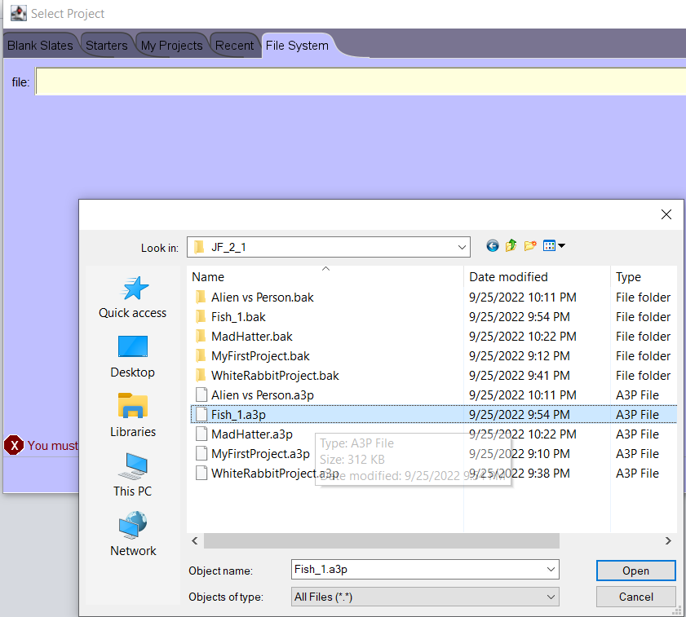Either using the My Projects tab or the File System tab, browse for and open the Fish_1.a3p file.
    3. Using the Save As command from the file menu, and rename the file to Fish_2.a3p.



* + 1. Ensure that you are in the scene editor.

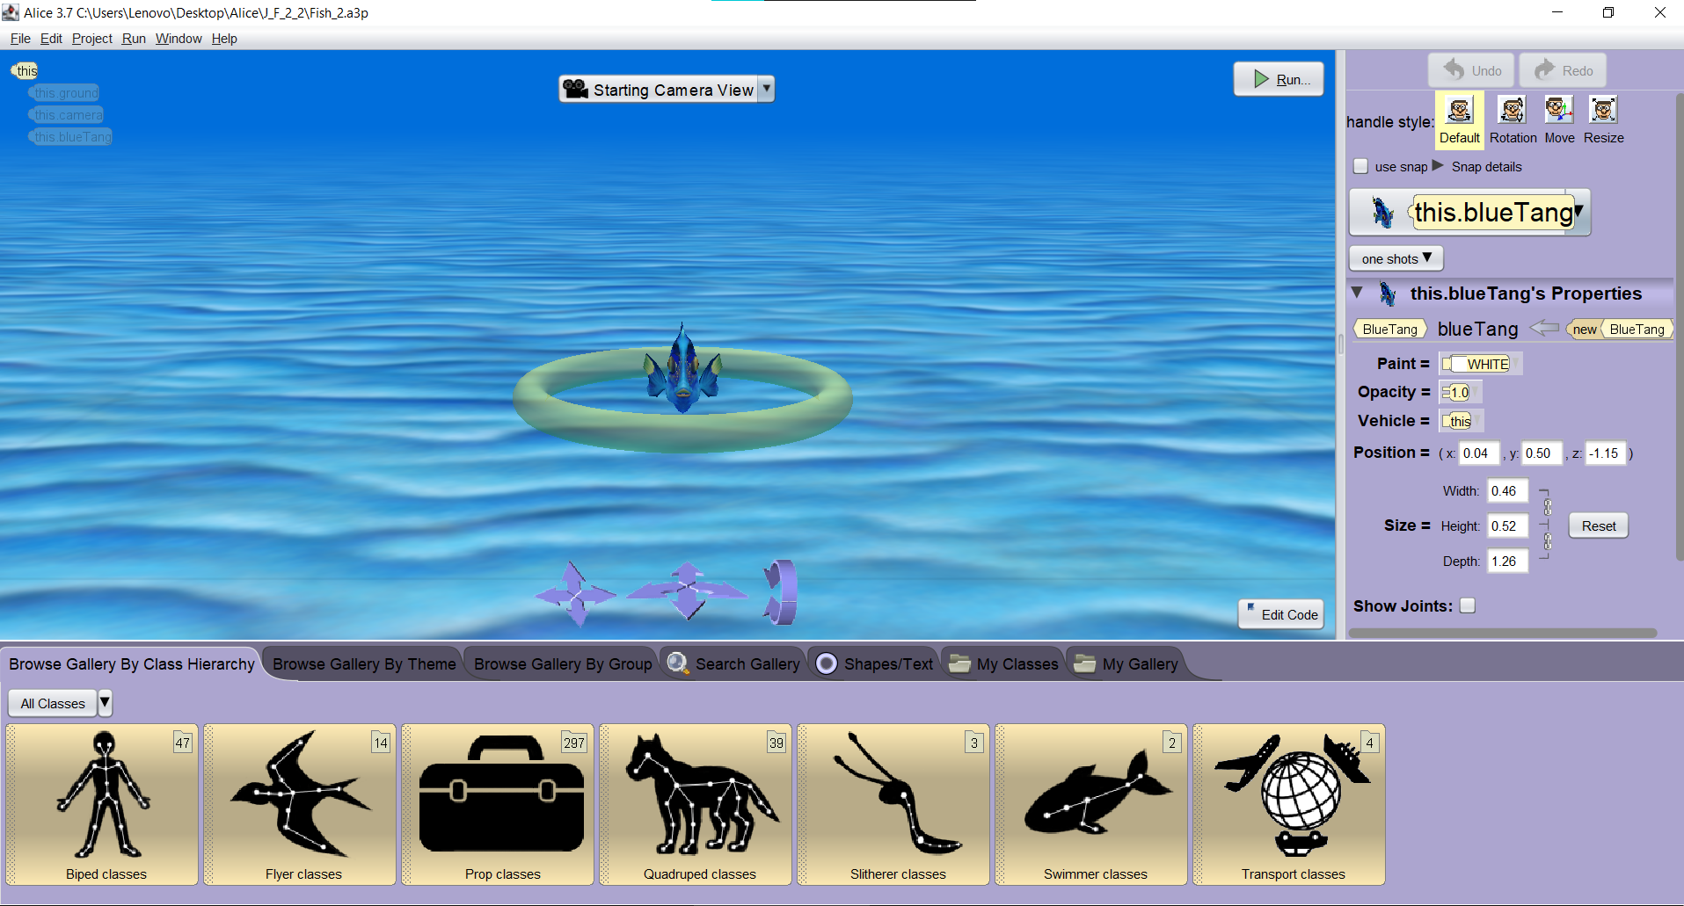

* + 1. Go to the fish classes menu which is found inside the swimmer classes gallery option.

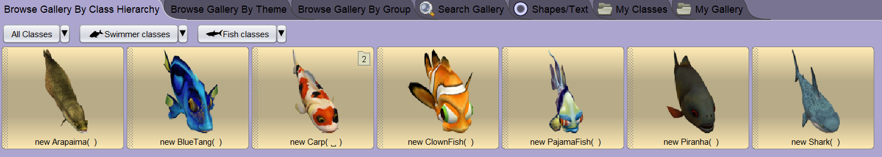

* + 1. Add a ClownFish and PajamaFish by clicking on them and accepting the default values. All the fish will be placed in the centre of the screen.

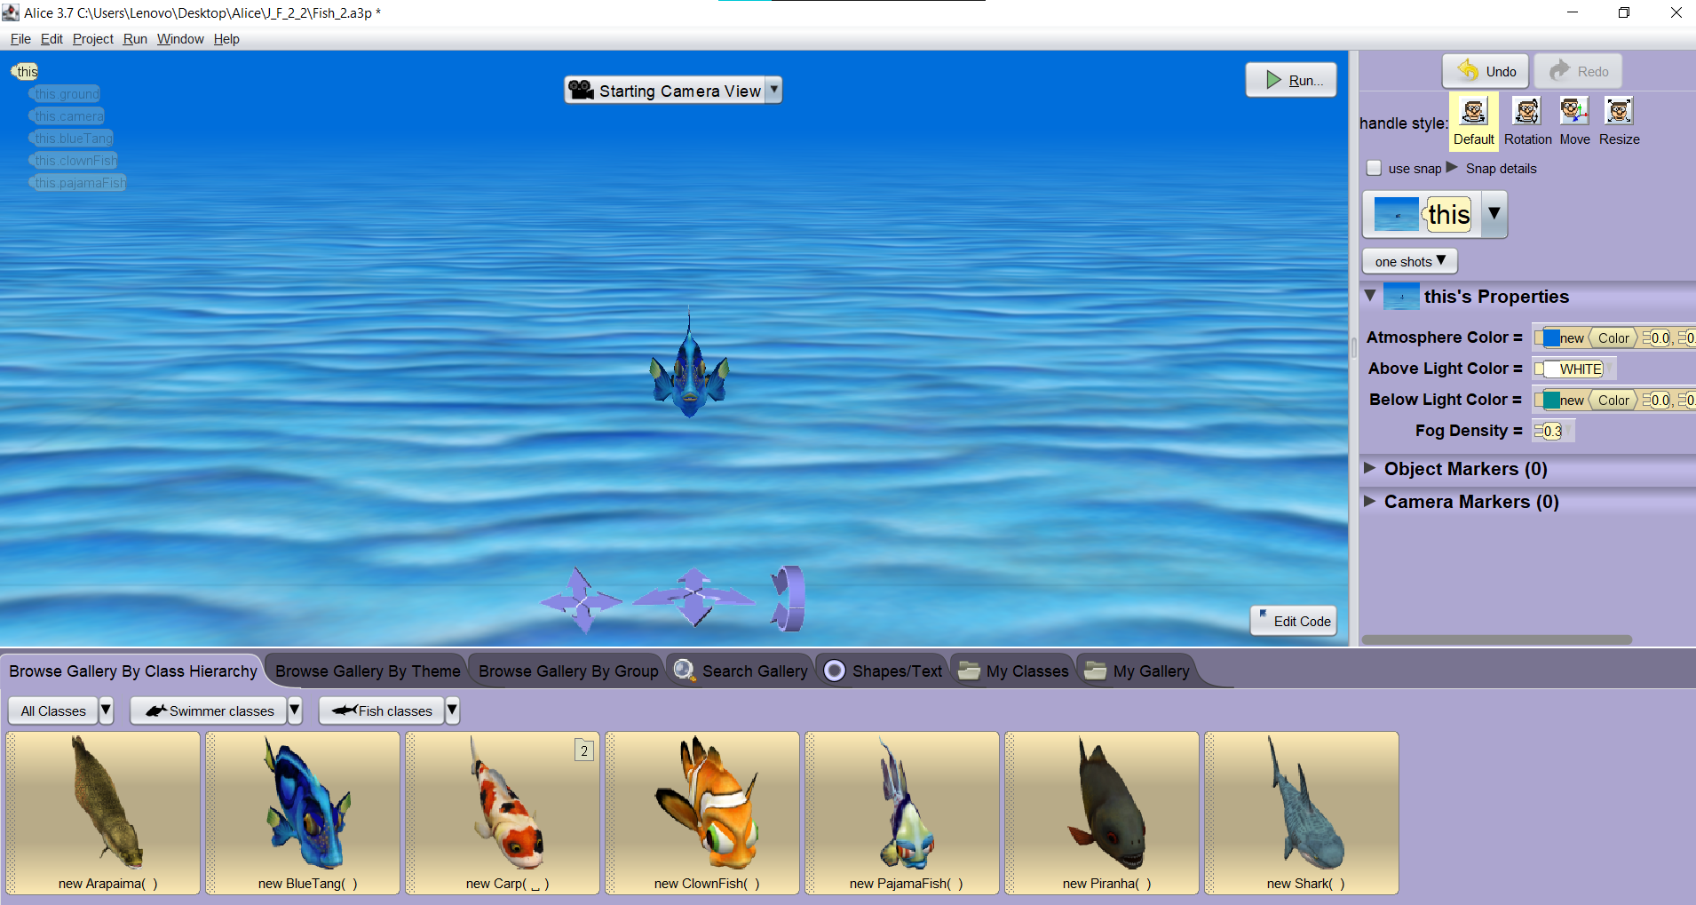

* + 1. Select the PajamaFish from the Object list drop down menu and use a one shot procedure to precisely position the PajamaFish 2.0 metres to the left.

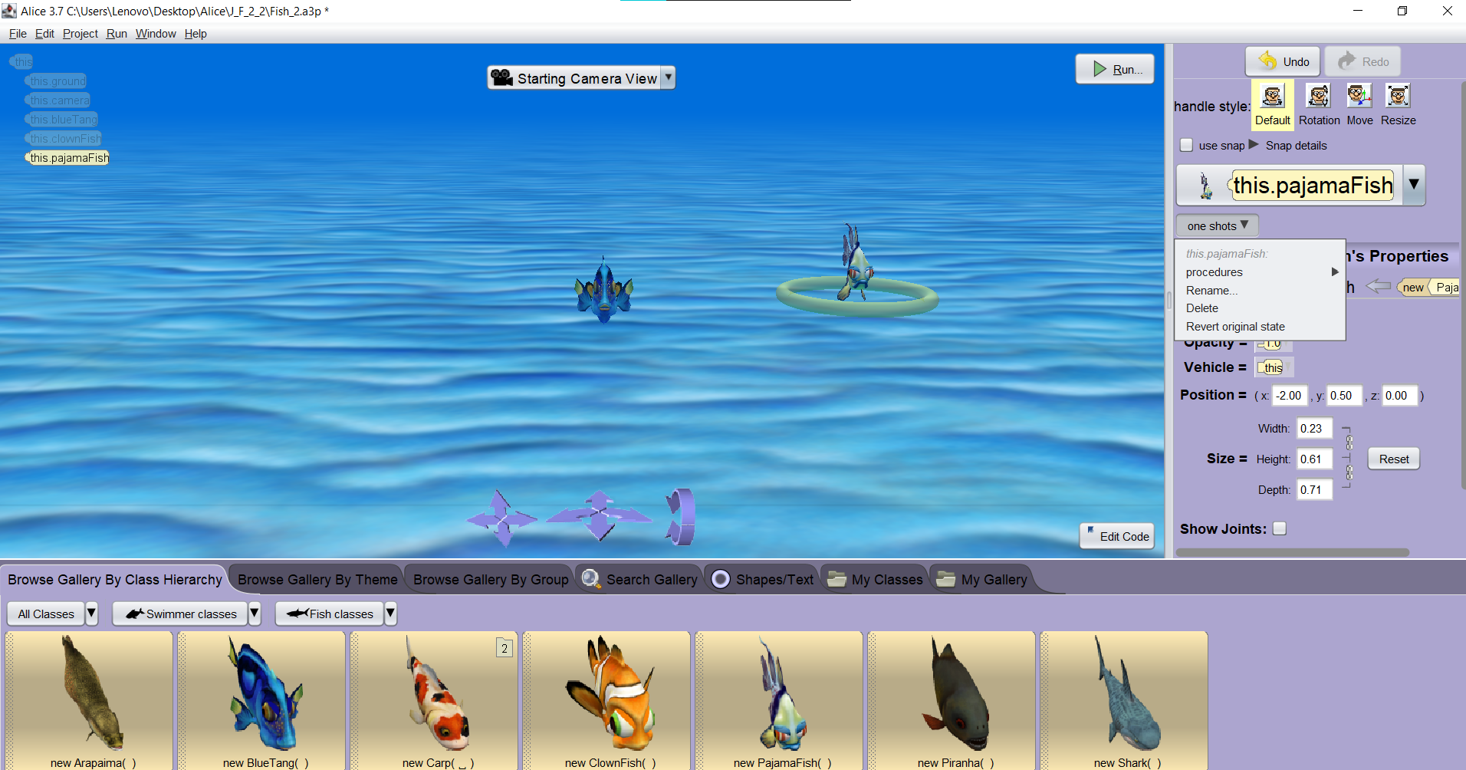

* + 1. Select the ClownFish from the Object list drop down menu and set X, Y and Z co-ordinates to the following values 2.0, .5 & 0.0 respectively. Press the Enter key when you have entered the co-ordinates to execute the change.

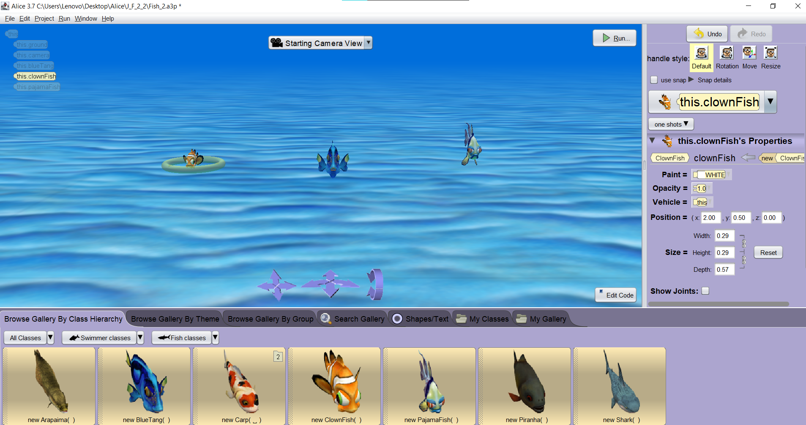

* + 1. 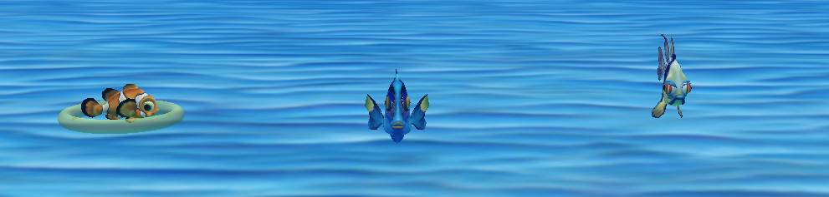With the ClownFish selected use a one-shot procedure to turnToFace the BlueTang fish.
    2. Select the PajamaFish and use a turnToFace one shot procedure to turn the PajamaFish to face the camera.

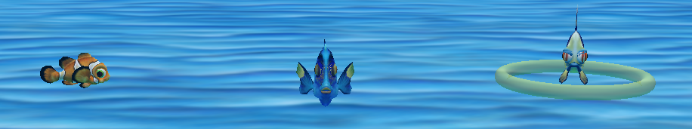

* + 1. Select the BlueTang fish from the object list and choose the resize handle. Drag the arrow beside the BlueTang fish away from the fish to make it or code the size values in the properties box using width 0.60, height 0.67 and a width of 1.65.

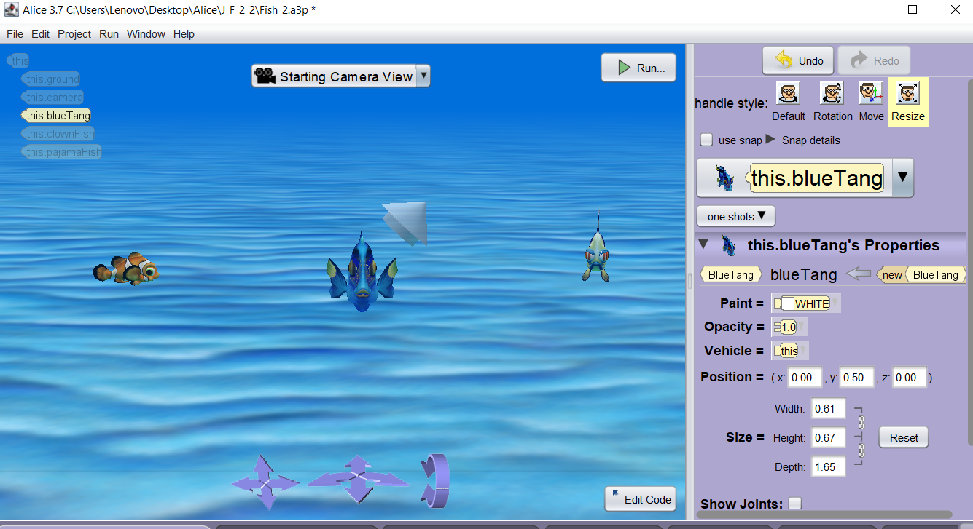

* + 1. Use the search tab in the gallery to search for TreasureChest

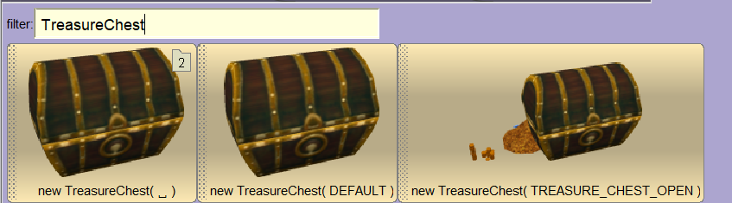

* + 1. 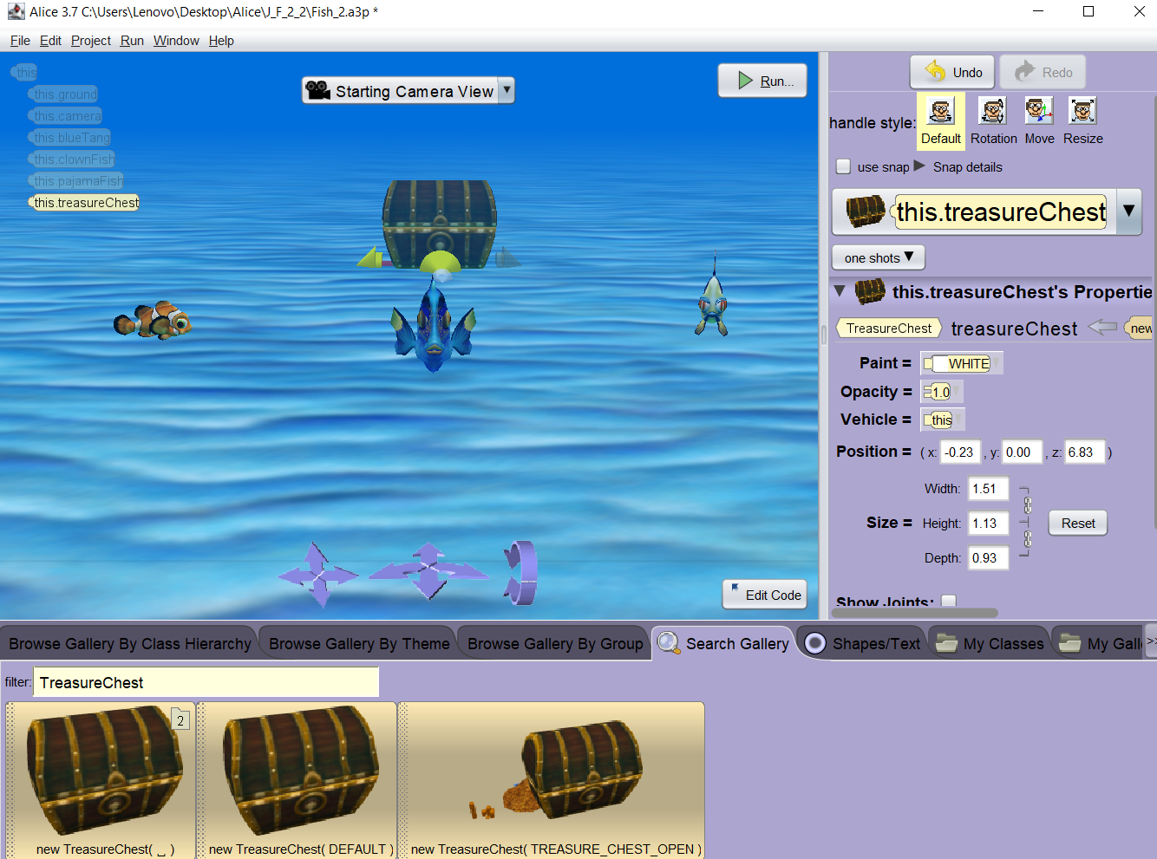Add the TreasureChest(DEFAULT) to your world using default settings
    2. Rotate, Resize and position it according to the following image.

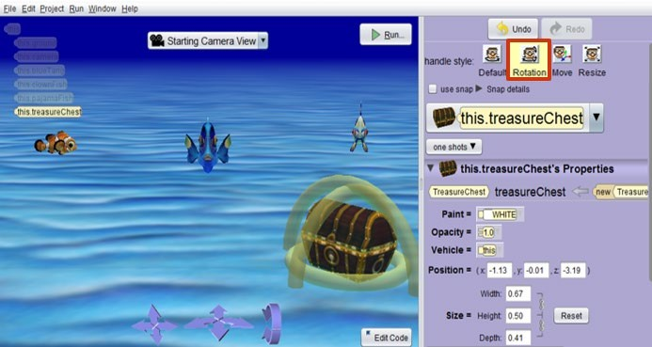

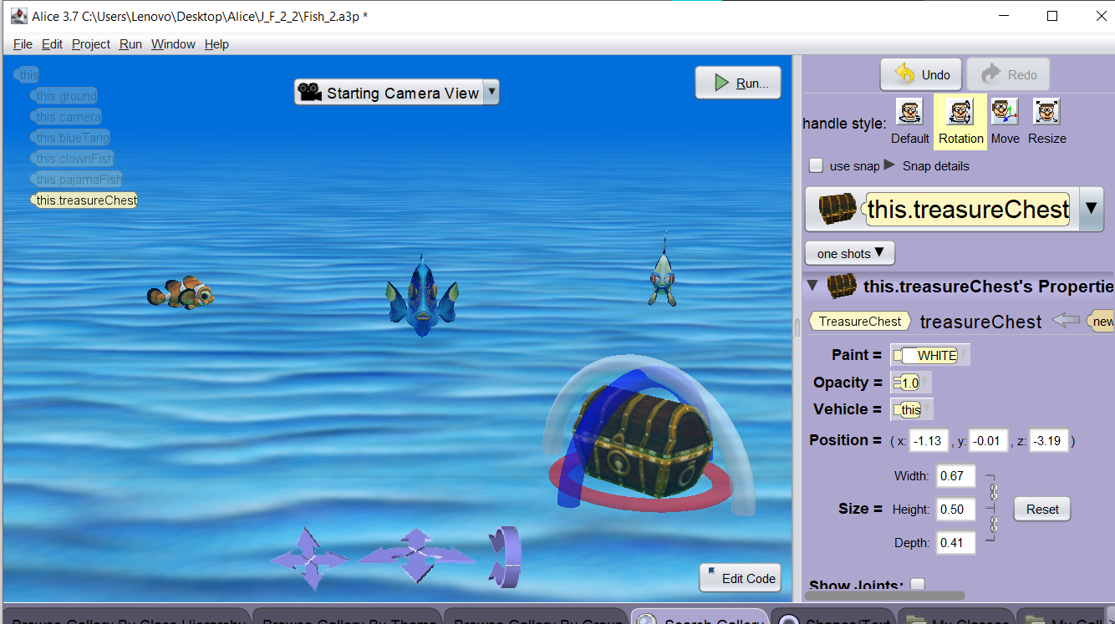

* + 1. Using the move tool lower the treasure chest so that it is just under the surface of the sea floor.

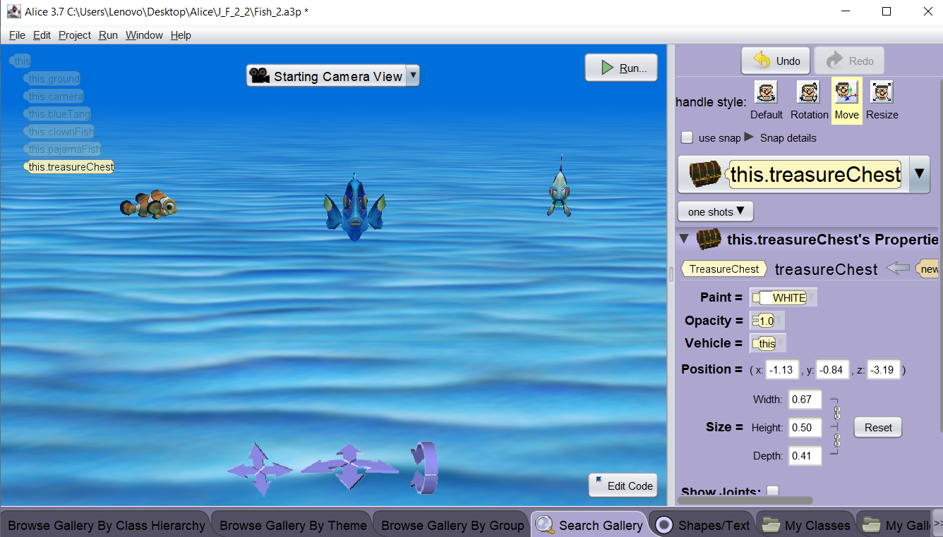

* + 1. Use the Edit Code button to return to the code editor.

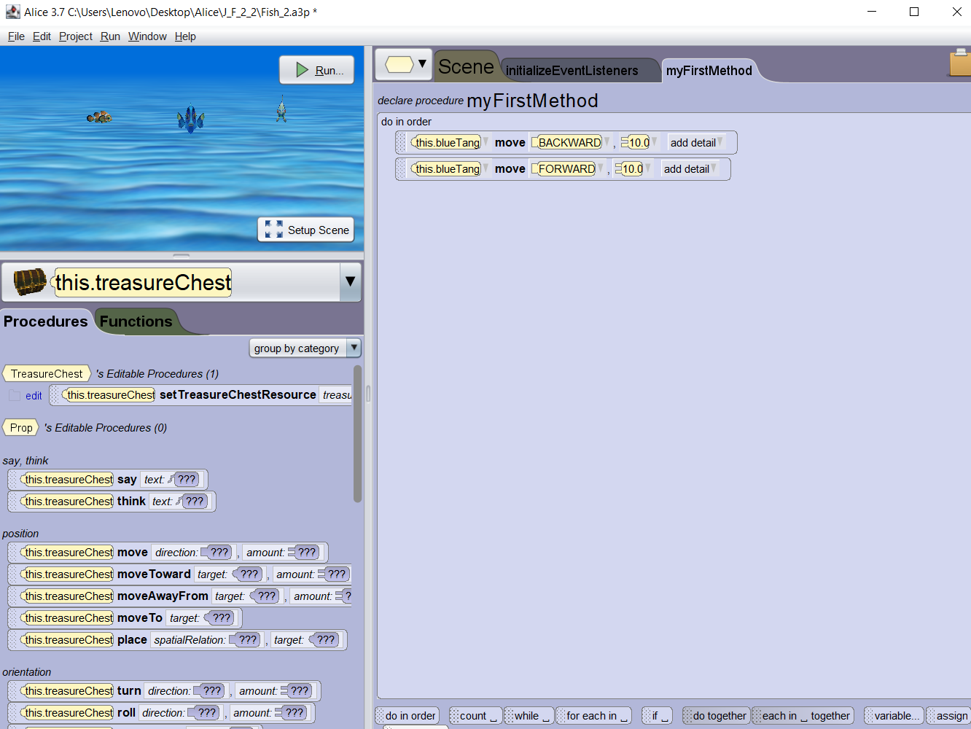

* + 1. Use the save command in the file menu to save your program.

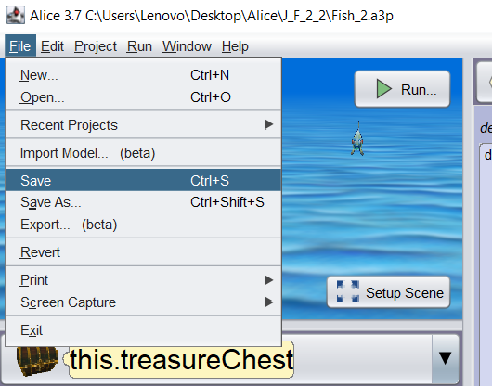

* + 1. Use the exit command in the file menu or the X button () to close down Alice 3.

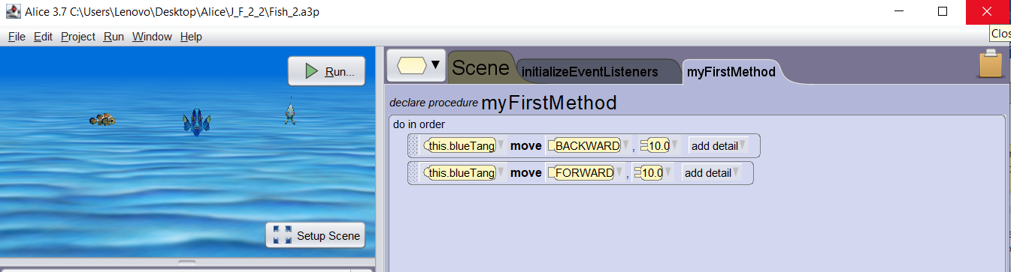

Copyright © 2021, Oracle and/or its affiliates. Oracle, Java, and MySQL are registered trademarks of Oracle and/or its affiliates. Other names may be trademarks of their respective owners.

2